HAND OUTS

HERMENEUTICS & STUDY TOOLS COHORT

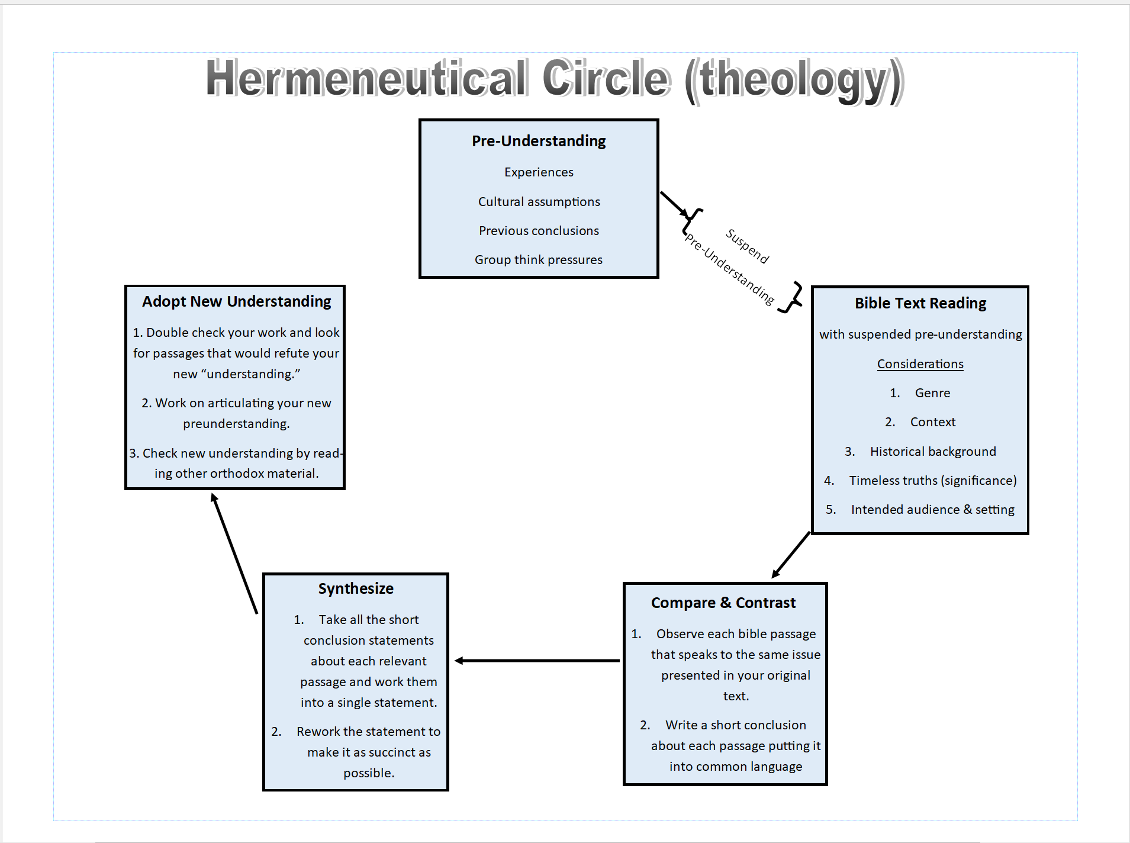
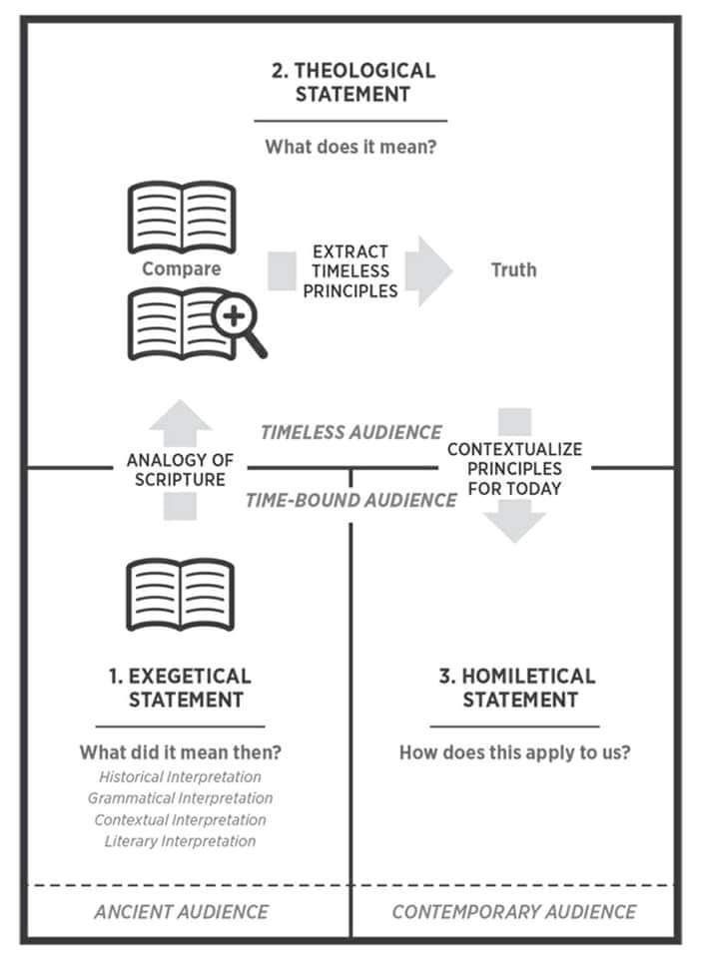

Hermeneutical Circle Illustration
By
Michael Patton

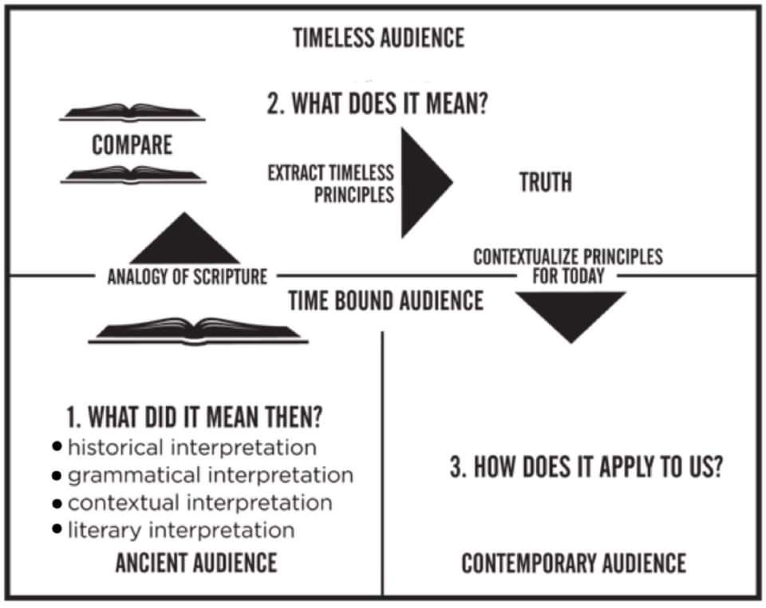

English Bible Translations
Word for Word vs Thought for Thought

By
Michael A Thompson

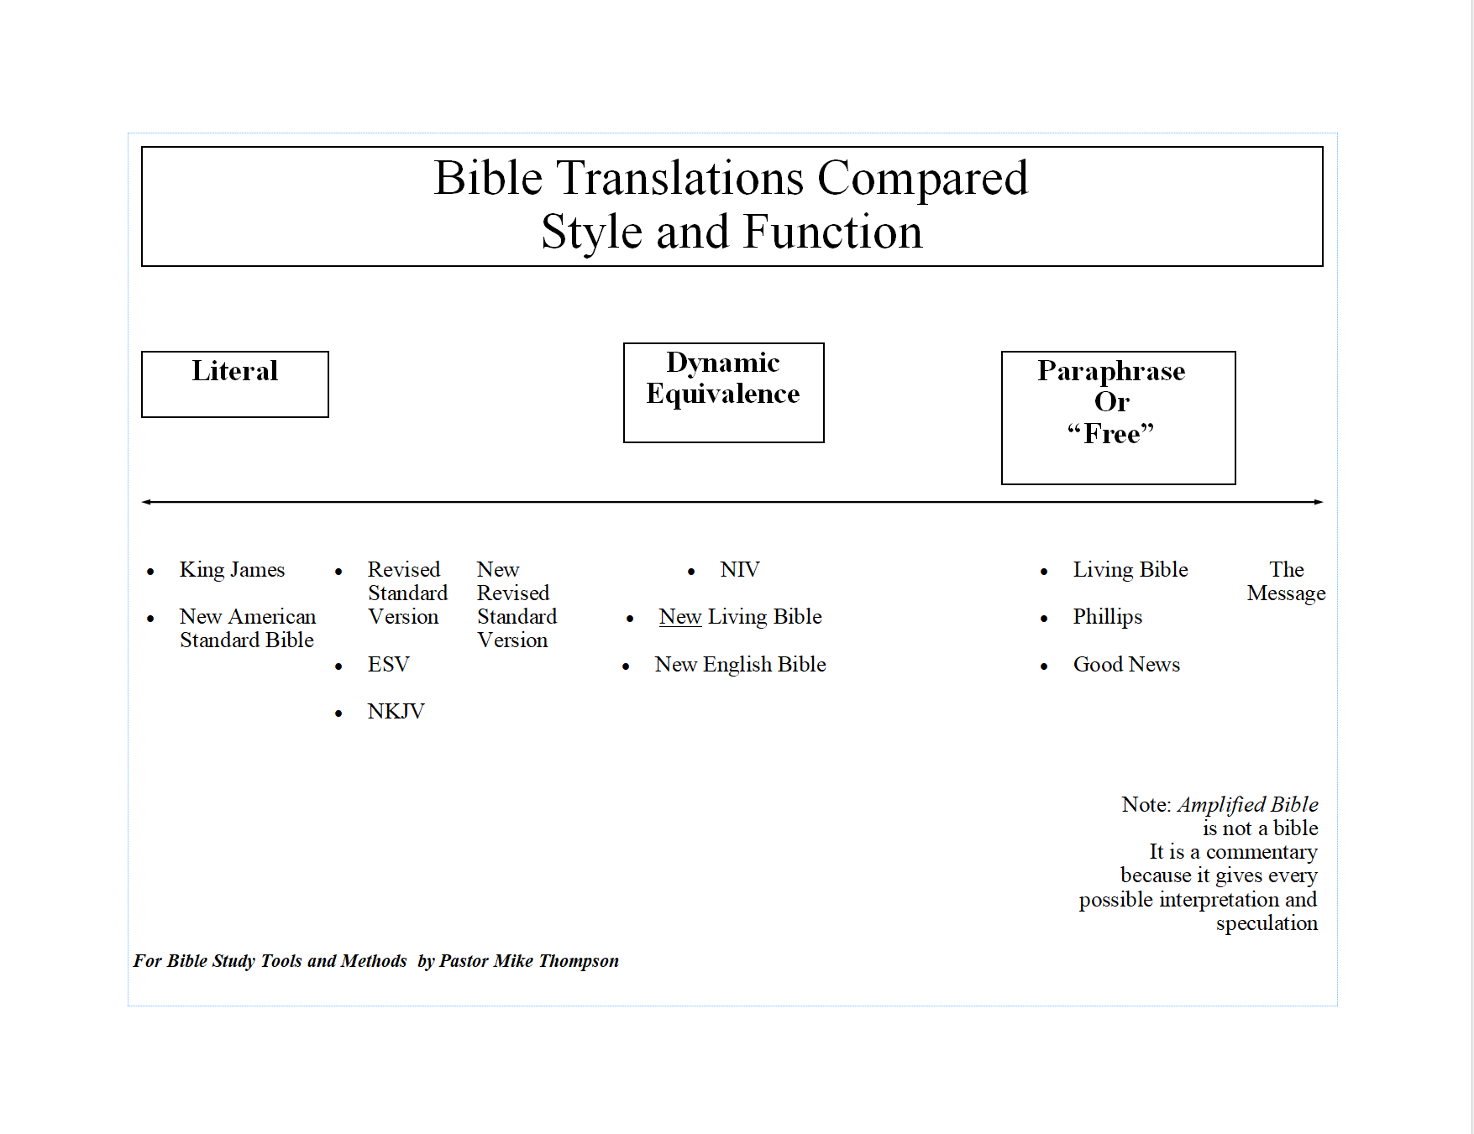

THE VALUE OF OBSERVATION

Page 1
The Student, The Fish, and Agassiz
By the Student
It was more than fifteen years ago that I entered the laboratory of Professor Agassiz, and told him I had enrolled my name in the scientific school as a student of natural history. He asked me a few questions about my object in coming, my antecedents generally, the mode in which I afterwards proposed to use the knowledge I might acquire, and finally, whether I wished to study any special branch. To the latter I replied that while I wished to be well grounded in all departments of zoology, I purposed to devote myself specially to insects.
“When do you wish to begin?” he asked. “Now,” I replied. This seemed to please him, and with an energetic “Very well,” he reached from a shelf a huge jar of specimens in yellow alcohol. “Take this fish,” said he, “and look at it; we call it a Haemulon [pronounced Hem- yú- lon]; by and by I will ask what you have seen.” With that he left me, but in a moment returned with explicit instructions as to the care of the object entrusted to me. “No man is fit to be a naturalist,” said he, “who does not know how to take care of specimens.”
I was to keep the fish before me in a tin tray, and occasionally moisten the surface with alcohol from the jar, always taking care to replace the stopper tightly. Those were not the days of ground glass stoppers, and elegantly shaped exhibition jars; all the old students will recall the huge, neckless glass bottles with their leaky, wax-besmeared corks half eaten by insects and begrimed with cellar dust. Entomology was a cleaner science than ichthyology, but the example of the professor, who had unhesitatingly plunged to the bottom of the jar to produce the fish, was infectious; and though this alcohol had “a very ancient and fishlike smell,” I really dared not show any aversion within these sacred precincts, and treated the alcohol as though it were pure water. Still I was conscious of a passing feeling of disappointment, for gazing at a fish did not commend itself to an ardent entomologist. My friends at home, too, were annoyed, when they discovered that no amount of eau de cologne would drown the perfume which haunted me like a shadow. In ten minutes I had seen all that could be seen in that fish, and started in search of the professor, who had, however, left the museum; and when I returned, after lingering over some of the odd animals stored in the upper apartment, my specimen was dry all over. I dashed the fluid over the fish as if to resuscitate it from a fainting-fit, and looked with anxiety for a return of the normal, sloppy
Page 2
The Student, The Fish, and Agassiz
Page:2
appearance. This little excitement over, nothing was to be done but return to a
steadfast gaze at my mute companion. Half an hour passed, an hour, another hour; the fish began to look loathsome. I turned it over and around; looked it in the face—ghastly; from behind, beneath, above, sideways, at a three-quarters’ view—just as ghastly. I was in despair; at an early hour I concluded that lunch was necessary; so, with infinite relief, the fish was carefully replaced in the jar, and for an hour I was free.
On my return, I learned that Professor Agassiz had been at the museum, but had gone and would not return for several hours. My fellow students were too busy to be disturbed by continued conversation. Slowly I drew forth that hideous fish, and with a feeling of desperation again looked at it. I might not use a magnifying glass; instruments of all kinds were interdicted. My two hands, my two eyes, and the fish; it seemed a most limited field. I pushed my finger down its throat to feel how sharp its teeth were. I began to count the scales in the different rows until I was convinced that that was nonsense. At last a happy thought struck me—I would draw the fish; and now with surprise I began to discover new features in the creature. Just then the professor returned.
“That is right,” said he; “a pencil is one of the best of eyes. I am glad to notice, too, that you keep your specimen wet and your bottle corked.”
With these encouraging words he added,— “Well, what was it like?”
He listened attentively to my brief rehearsal of the structure of parts whose names were still unknown to me: the fringed gill—arches and movable operculum; the pores of the head, fleshy lips, and lidless eyes; the lateral line, the spinous fin, and forked tail; the compressed and arched body. When I had finished, he waited as if expecting more, and then, with an air of disappointment,— “You have not looked very carefully; why,” he continued, more earnestly, “you haven’t seen one of the most conspicuous features of the animal, which is as plainly before your eyes as the fish itself; look again, look again!” and he left me to my misery. I was piqued; I was mortified. Still more of that wretched fish! But now I set myself to my task with a will, and discovered one new thing after another, until I saw how just the professor’s criticism had been. The afternoon passed quickly, and when, towards its close, the professor inquired,— “Do you see it yet?” “No,” I replied, “I am certain I do not, but I see how little I saw before.” “That is next best,” said he earnestly, “but I won’t hear you now; put away your fish and go home; perhaps you will be ready with a better answer in the morning. I will examine you before you look at the fish.”

Page 3
The Student, The Fish, and Agassiz
Page:3
This was disconcerting; not only must I think of my fish all night, studying, without the object before me, what this unknown but most visible feature might be; but also, without reviewing my new discoveries, I must give an exact account of them the next day. I had a bad memory; so I walked home by Charles River in a distracted state, with my two perplexities. The cordial greeting from the professor the next morning was reassuring; here was
a man who seemed to be quite as anxious as I that I should see for myself what he saw. “Do you perhaps mean,” I asked, “that the fish has symmetrical side with paired organs?” His thoroughly pleased, “Of course, of course!” repaid the wakeful hours of the previous night. After he had discoursed most happily and enthusiastically—as he always did—upon the importance of this point, I ventured to ask what I should do next.
“Oh, look at your fish!” he said, and left me again to my own devices. In a little
more than an hour he returned and heard my new catalogue. “That is good, that is good!” he repeated, “but that is not all; go on.” And so, for three long days, he placed that fish before my eyes, forbidding me to look at anything else, or to use any artificial aid. “Look, look, look,” was his repeated injunction.
This was the best entomological lesson I ever had—a lesson whose influence has extended to the details of every subsequent study; a legacy the professor has left to me, as he has left it to many others, of inestimable value, which we could not buy, with which we cannot part. A year afterward, some of us were amusing ourselves with chalking outlandish beasts upon the museum blackboard. We drew prancing star-fishes; frogs in mortal combat; hydra-headed worms; stately craw-fishes, standing on their tails, bearing
aloft umbrellas; and grotesque fishes, with gaping mouths and staring eyes. The
professor came in shortly after, and was amused as any, at our experiments. He
looked at the fishes.
“Haemulons, every one of them,” he said. “Mr. ---------- drew them.”
True; and to this day, if I attempt a fish, I can draw nothing but Haemulons.
The fourth day, a second fish of the same group was placed beside the first, and I was bidden to point out the resemblances and differences between the two;
another and another followed, until the entire family lay before me, and a whole legion of jars covered the table and surrounding shelves; the odor had become a pleasant perfume; and even now, the sight of an old, six-inch, worm-eaten cork brings fragrant memories!

Page 4
The Student, The Fish, and Agassiz
Page:4
The whole group of Haemulons was thus brought in review; and, whether engaged upon the dissection of the internal organs, the preparation and examination of the bony framework, or the description of the various parts, Agassiz’s training in the method of observing facts and their orderly arrangement was ever accompanied by the urgent exhortation not to be content with them.
“Facts are stupid things,” he would say, “until brought into connection with some general law.”
At the end of eight months, it was almost with reluctance that I left these friends and turned to insects; but what I had gained by this outside experience has been of greater value than years of later investigation in my favorite groups.
From American Poems (3d ed.; Boston: Houghton, Osgood and Co., 1879), pp. 450-54. This essay first appeared in Every Saturday, XVI (Apr. 4, 1874), 369-70, under the title “In the Laboratory, With Agassiz, By a former pupil.”

Anxiety Charting Bible Passages

By

Michael A Thompson

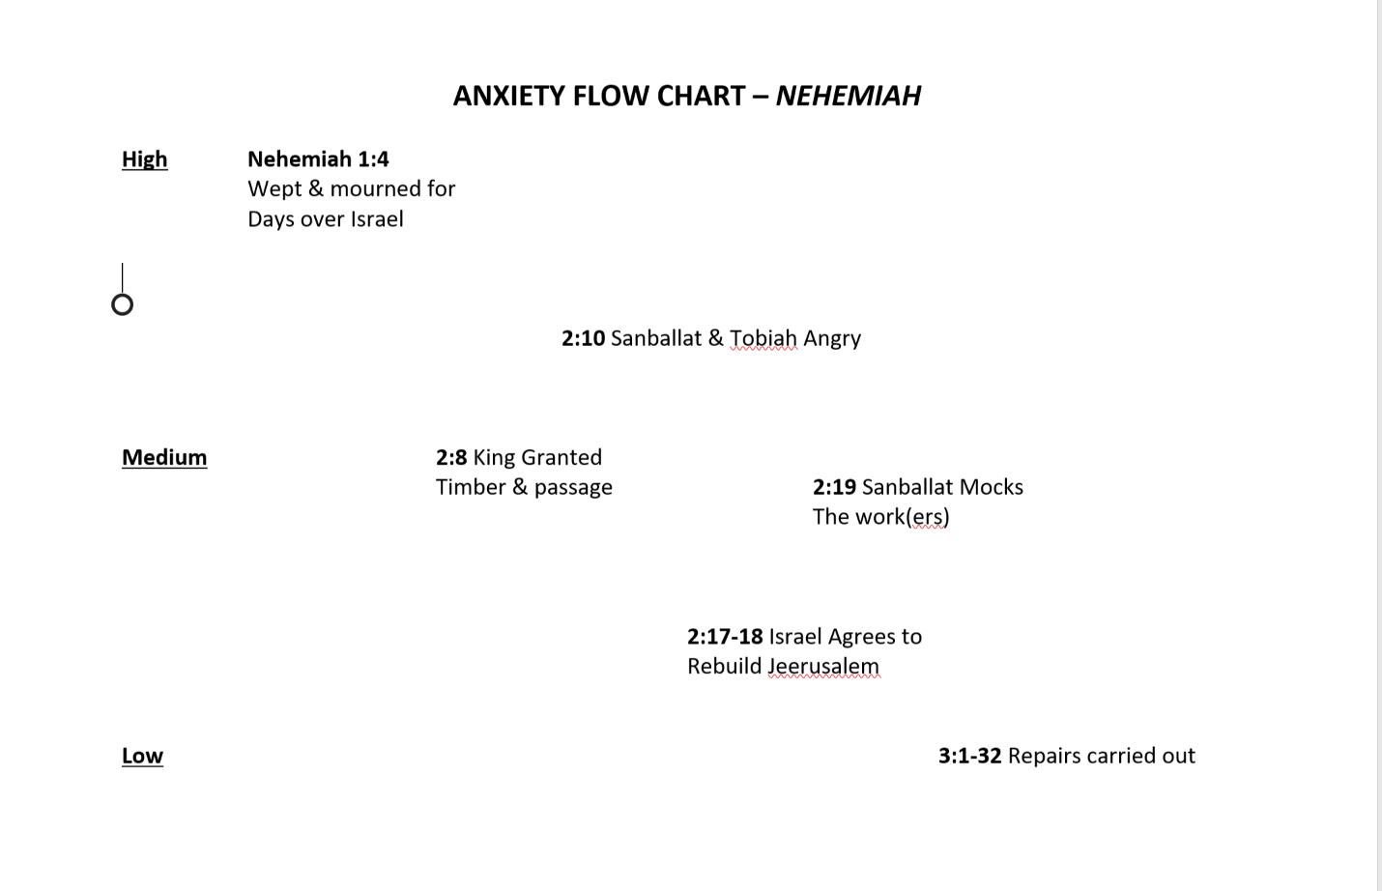

NOTE: God is the hero of all bible narratives. Pressures and stressors from circumstances and foes raise our anxiety levels. But God, faithful to His promises and purposes rescues God’s people consistently. This is a primary story line of scripture. God promised to establish His kingdom and use the seed of the women to crush the head of the serpent.

Just when the serpent and his offspring advance against the seed of the woman (God’s people), our great God and Savior comes to the rescue providing a means of escape and salvation.

Debate Techniques
How can they help us in hermeneutics and theology?

Pasted below are article excerpts focusing on debate techniques. Expressing our theological conclusions is similar to debate, in that we want our position to be persuasive. Here are a few ideas that may help us be more persuasive in our theological presentation and discussions (including our preaching).

1) Develop structured arguments, not just claims.
The best debaters know that a sound argument is made up of three main components: the claim, the data, and the warrant.
The claim is the central idea you're asserting. It usually takes the form of a specific statement that directly supports your main resolution, e.g.: "Conversion optimizing your website will bring in more leads for your business." When presented on its own, the claim is essentially worthless to your argument. It doesn't prove anything, it's just a statement.

The data is the evidence that supports your claim. Think of yourself like a lawyer stating your case: Without the right facts to back up your claims, your case is pretty much meaningless.
Data doesn't have to mean hard statistics. Draw from your previous client success stories, case studies, or even industry trends to beef up your case.
The warrant is the bridge that connects your data to your claim, e.g.: "Because many other companies in your industry have found success with conversion optimization, we believe that conversion optimizing your website will bring in more leads for your business." The "because" statement explains why exactly the data backs up the claim.
Before your pitch, plan out your main arguments by identifying the claim, data, and warrant for each point. This approach can help you identify weak spots in your presentation.

If you can't adequately support one of your claims, it's a good sign you need to dig in deeper or scrap it completely.

2) Anticipate opposition, and counter it. (REJOINDER)
Your prospective clients aren't exactly the opposition (you want to end up working with them, after all), but they will be looking for places in your presentation that seem weak or opposed to their goals. And the best way to prepare for the inevitable onslaught of questions is to
think like your very worst critic.

There are two fundamental kinds of opposition you're likely to face. The first is a rebuttal, which is data or evidence that disagrees with one of your claims.
For example, if you presented the claim that conversion optimizing your prospect's website will get them more leads, a rebuttal to this claim would be an anecdote about a business that conversion optimized their website and didn't generate more leads. This evidence is in direct opposition to your claim.

The second kind of opposition you might face is a counterclaim. While a rebuttal refutes a claim you presented with new evidence, a counterclaim brings up a new claim that directly opposes your own.
For example, if you presented the claim that conversion optimizing your prospect's website is the smartest way to yield more leads, a counterclaim would be that SEO is in fact the better strategy.
How can you prepare for rebuttals and counterclaims?

Comb through your presentation (or theological position) with a ruthless eye and create your own list of opposing points. Then practice how you would address them before the pitch.

This will ensure you aren't forced to think on your feet when the stakes are high.

3) Address all questions head-on.
In debate, if you fail to fully address an argument from the opposing team, it's taken as a concession.

It's essentially the same thing as admitting their argument is correct.

This is called a drop, as in: You completely dropped the ball.
During your pitch, it's easy to become so focused on crushing your presentation that you stumble when the prospective client expresses concerns or raises questions you hadn't considered. It's important that you give a complete, honest answer to each of their questions, even if the answer is, "I'm not sure right now, but I will find out and get back to you."
Glossing over a concern or not fully answering a question will look far worse to the prospect than attempting to answer to the best of your ability and stumbling a bit. At least it lets the prospect know that you heard them, you understand where they're coming from, and you're interested in getting them the right information.

DEBATE TECHNIQUES APPLIED
TO THEOLOGICAL, PREACHING AND APOLOGETICS

- Don’t make “claims” that are unsubstantiated. For example; an Arminian might reject predestination because he “just can’t see it,” to him “it just doesn’t seem fair that God would remove all human choice!” This however, is a claim without authority. The speaker is appealing to his sense of fairness, rather than the word of God. Similarly, an Augustinian theologian, in defense of his view of God’s sovereignty may claim, “well God has to be in charge of everything.” “If you left things up to people, nothing good would happen!” This claim is not based on scripture, but, rather, on the Augustinian’s view of humanity. He may be correct, however, the Augustinian has not established his primary point using scriptures, namely, the Sovereignty of God over the affairs of humanity.
- The used of rejoinder: Rejoinder involves suspending judgment while investigating in the serious manner the claims of those who oppose your theological or apologetical view. It involves looking for the weaknesses of your view while observing the ways in which scripture substantiates some (or all) of your opponent’s viewpoint. It is possible that two seemingly opposing view are supported by the bible text. If there are two seemingly opposing views supported by scripture, the struggle is not to determine which is correct, but how to assimilate both of these views properly into a coherent theology that is currently not being considered. For example; the Westminster Confession affirms BOTH predestination and free will in a well-constructed coherent statement.
- Address questions directly: It is tempting to ignore questions and propositions for which one has not prepared. One commonly used method of addressing theological and apologetical questions is to ignore the question posed and continue to state one’s own conviction louder than the first time it was expressed. If one is unprepared to answer an objection or another’s point of view, it is better to be honest than to obfuscate by changing the subject. When debating or presenting points of view, if some of those points are unfamiliar, I have found it mutually satisfying to state; “I will research your question (or point of view) more, and would love to reengage at a later time.”

Note: While preaching emphatically, the speaker is seen as more credible when also presenting honestly the opposing view point before presenting their own view.

One Two Threes of Meaning

(For A Single Bible Passage)

- Read the entire book or letter

- Go to the passage in question

- Read a few paragraphs before and after your text to understand the context

- Take into account the historical setting of the author and issues the book addresses

- Take into account the type of literature you are reading

- Determine the plain meaning of the author as applied to the author’s intended audience.

- Come up with points of significant or applications without stretching the basic meaning of the text

- Consult commentaries or Christian leaders to see if you are on the right track

One Two Threes of Theology

- Use a concordance or computer word search to locate all the passages in the bible that speak to your subject

- Use the guidelines above so that you understand the meaning of each text

- Weed out passages that do not apply to the topic you are researching

- Create some summary statements that are big enough to include all the passages making sure not violate the plain meaning of any passage

- Remember: Your theology or summary statement cannot change the plain meaning of any passage. The plain meaning of every passage trumps all theology statements.

- Do not make a theology out of an unclear or a single passage (unless that single passage is as certain as snow in Wisconsin)

Research Tools

- Study bible with cross references
- Concordance (on line or hardcover) (where to find it in Scripture is good)
- Bible background commentary (IVP)
- Commentaries (Life Application bible commentary is great for laity)
- Bible dictionary (tells you expanded info about many topics)
- Theology commentary (I like Grudem’s “Systematic Theology”)
- Internet (bible.com or biblegateway.org has all the bibles and many research tools)

Theology or Ethic Worksheet

- What does The Bible say about (name the subject)_____________________________?

Example: Ask very specific questions about your subject. For example, if your question relates to baptism, form your question narrowly and specifically before you begin looking up passages.

Sample Questions: 1. Should a person be baptized before they become a believer? 2. What method is used to baptize individuals in the New Testament? 3. In scripture who should perform a baptism ceremony?
PASSAGE LOOK UPS
Plain meaning of a passage is determined by observing the
Text, Context, Historical Background, Timeless-Truths
of each passage. Remember genre and context for each passage.

2. Look up all passages that speak to your topic and then whittle them down to about 4 or 5 of the most relevant ones. Make sure they related to the questions you wrote. List them below.

Passage One: __________

Plain meaning: ______________

Passage Two: __________

Plain meaning: ______________

Passage Three: __________

Plain meaning: ______________

HARMONIZE
Compare Scripture with Scripture

In this process you compare scripture with scripture to harmonize them into a single statement.

Considering all the relevant passages that you found, the bible says, about
(e.g. the best means of baptism)…..

3. Theology or Ethic Statement:(taken from a summary of passages)

___________________________________________________________

____________________________________________________________

THE ANALOGY OF FAITH

(Analogia fidei)

No part of Scripture should be interpreted in such a way as to render it in conflict with what it taught elsewhere in Scripture.
No single passage of scripture that is obscure may rule out one or several passages that are clear.

Scriptura Scripturae interpres;

...which means that the whole of scripture is to be the interpreter of the part. The singular text must yield to the plurality.
This principle does not mean, however, that a statement of Scripture cannot be accepted as authoritative and binding unless substantiated by other passages.
We cannot reject a biblical proposition or practice simply because it occurs but once in Scripture. Unsupported texts can not be excluded. A single passage of scripture that is unopposed by other more clear scripture is sufficient to form a doctrine.

Timeline of Bible Translation History
1,400 BC: The first written Word of God: The Ten Commandments delivered to Moses.
500 BC: Completion of All Original Hebrew Manuscripts which make up the 39 Books of the Old Testament.
200 BC: Completion of the Septuagint Greek Manuscripts which contain the 39 Old Testament Books AND 14 Apocrypha Books.
1st Century AD: Completion of All Original Greek Manuscripts which make up the 27 Books of the New Testament.
315 AD: Athanasius, the Bishop of Alexandria, identifies the 27 books of the New Testament which are today recognized as the canon of scripture.
382 AD: Jerome's Latin Vulgate Manuscripts Produced which contain All 80 Books (39 Old Test. + 14 Apocrypha + 27 New Test).
500 AD: Scriptures have been Translated into Over 500 Languages.
600 AD: LATIN was the Only Language Allowed for Scripture.
995 AD: Anglo-Saxon (Early Roots of English Language) Translations of The New Testament Produced.
1384 AD: Wycliffe is the First Person to Produce a (Hand-Written) manuscript Copy of the Complete Bible; All 80 Books.
1455 AD: Gutenberg Invents the Printing Press; Books May Now be mass-Produced Instead of Individually Hand-Written. The First Book Ever Printed is Gutenberg's Bible in Latin.
1516 AD: Erasmus Produces a Greek/Latin Parallel New Testament.
1522 AD: Martin Luther's German New Testament.
1526 AD: William Tyndale's New Testament; The First New Testament printed in the English Language.
1535 AD: Myles Coverdale's Bible; The First Complete Bible printed in the English Language (80 Books: O.T. & N.T. & Apocrypha).
1537 AD: Tyndale-Matthews Bible; The Second Complete Bible printed in English. Done by John "Thomas Matthew" Rogers (80 Books).
1539 AD: The "Great Bible" Printed; The First English Language Bible Authorized for Public Use (80 Books).
1560 AD: The Geneva Bible Printed; The First English Language Bible to add Numbered Verses to Each Chapter (80 Books).
1568 AD: The Bishops Bible Printed; The Bible of which the King James was a Revision (80 Books).
1609 AD: The Douay Old Testament is added to the Rheims New Testament (of 1582) Making the First Complete English Catholic Bible; Translated from the Latin Vulgate (80 Books).
1611 AD: The King James Bible Printed; Originally with All 80 Books. The Apocrypha was Officially Removed in 1885 Leaving Only 66 Books.
1782 AD: Robert Aitken's Bible; The First English Language Bible (KJV) Printed in America.
1791 AD: Isaac Collins and Isaiah Thomas Respectively Produce the First Family Bible and First Illustrated Bible Printed in America. Both were King James Versions, with All 80 Books.
1808 AD: Jane Aitken's Bible (Daughter of Robert Aitken); The First Bible to be Printed by a Woman.
1833 AD: Noah Webster's Bible; After Producing his Famous Dictionary, Webster Printed his Own Revision of the King James Bible.
1841 AD: English Hexapla New Testament; an Early Textual Comparison showing the Greek and 6 Famous English Translations in Parallel Columns.
1846 AD: The Illuminated Bible; The Most Lavishly Illustrated Bible printed in America. A King James Version, with All 80 Books.
1885 AD: The "English Revised Version" Bible; The First Major English Revision of the KJV.
1901 AD: The "American Standard Version"; The First Major American Revision of the KJV.
1971 AD: The "New American Standard Bible" (NASB) is Published as a "Modern and Accurate Word for Word English Translation" of the Bible.
1973 AD: The "New International Version" (NIV) is Published as a "Modern and Accurate Phrase for Phrase English Translation" of the Bible.
1982 AD: The "New King James Version" (NKJV) is Published as a "Modern English Version Maintaining the Original Style of the King James."
2002 AD: The English Standard Version (ESV) is Published as a translation to bridge the gap between the accuracy of the NASB and the readability of the NIV.

History of The English Bible Versions
Go to the following link to read in more detail about how each of the English bible versions was developed.
https://www.greatsite.com/timeline-english-bible-history/index.html

Hidden Poetry Within Another Genre
New Testament Example
(Colossians 1:15-20)
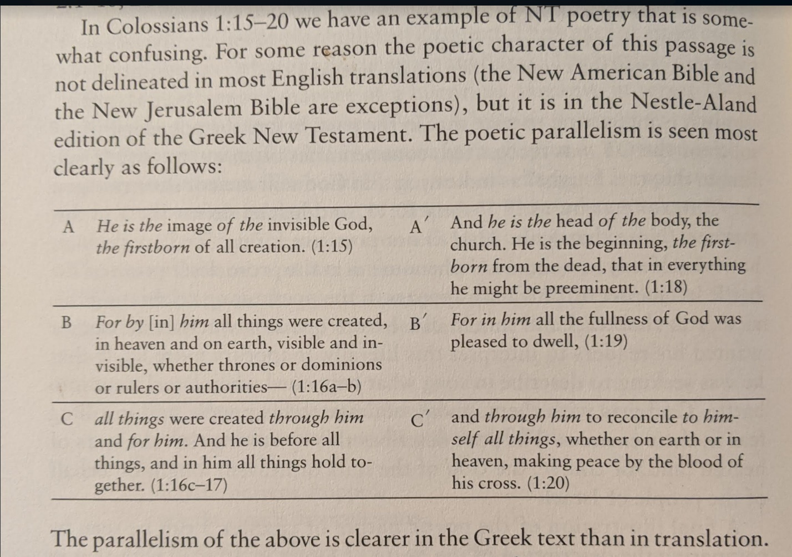

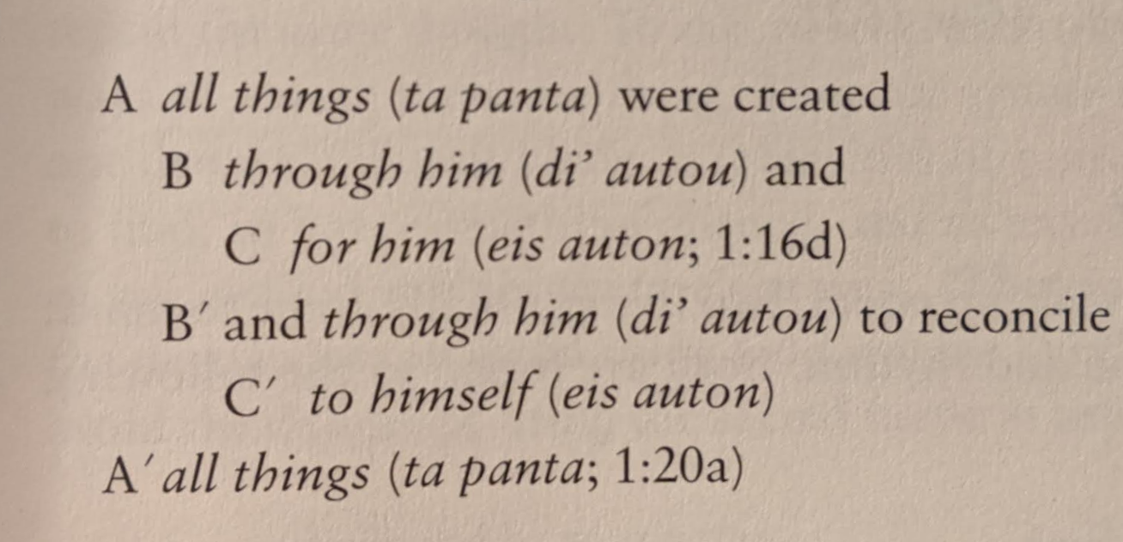
COVENANT
(From Joshua)

Example from Stein p 103

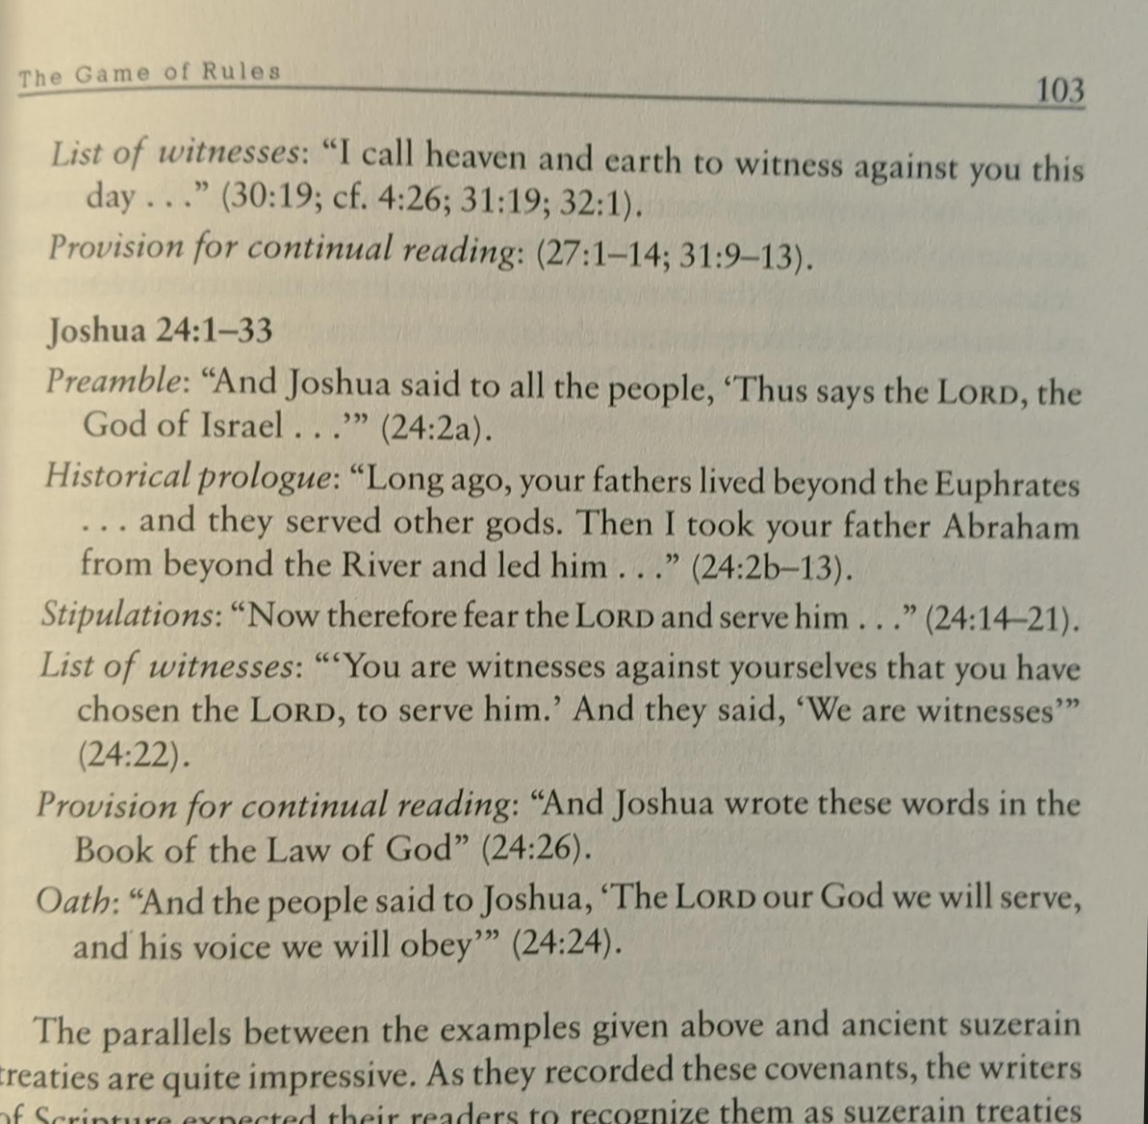

Biblical Covenants Example 2

From Stein’s Hermeneutics

