Hermeneutics / Diagnosis / Observation
Hard Sciences

QUESTION: HOW WOULD IT AFFECT OUR DIAGNOSIS IF WE SEARCH FOR PROOF OF OUR PRE-UNDERSTANDING?
(Example: what if we had political pressure to find global warming,
before we did the science?)

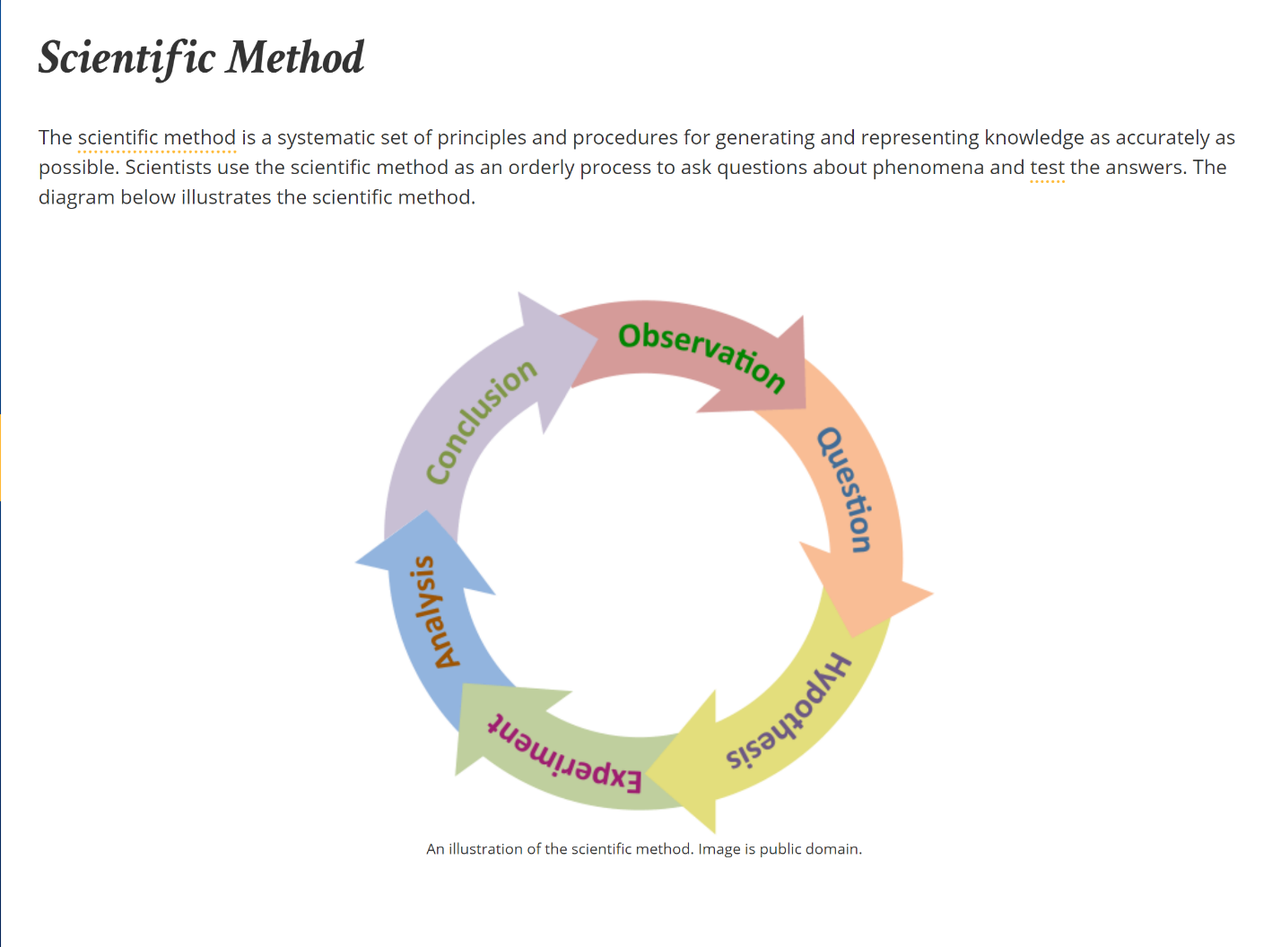

QUESTION: HOW WOULD IT AFFECT OUR DIAGNOSIS IF WE NEVER CONSIDER BIPOLAR?

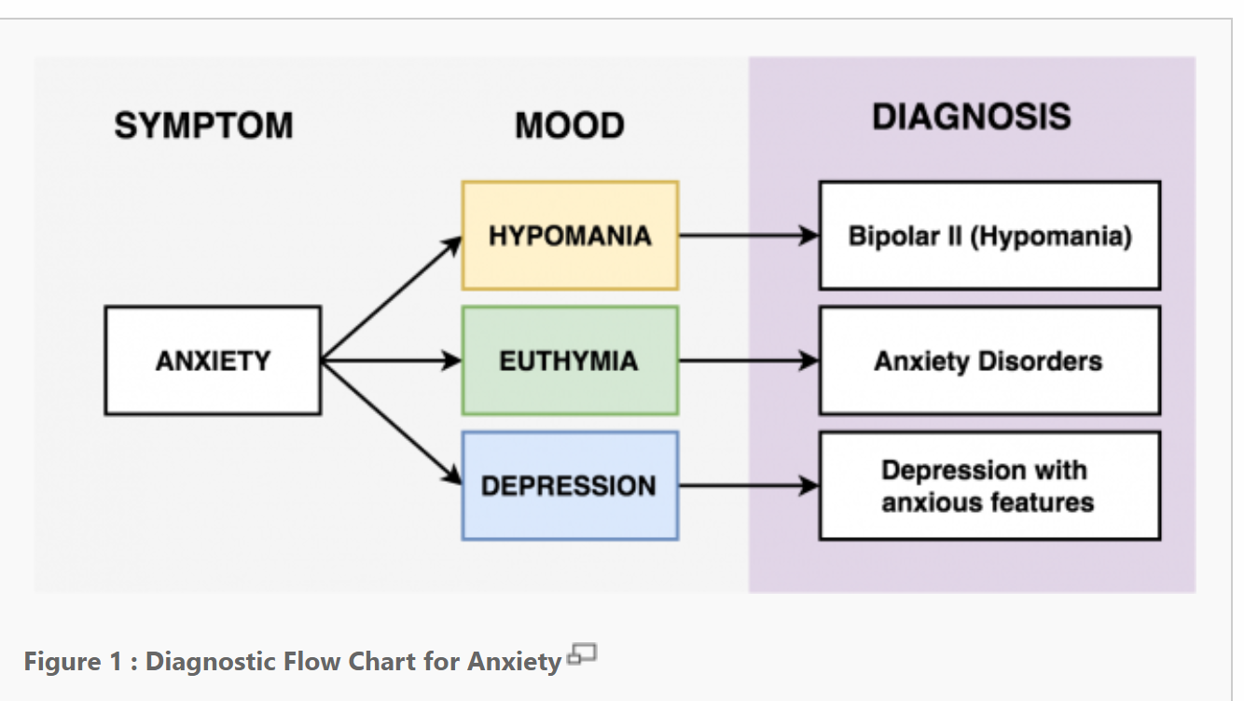

-QUESTION: HOW WOULD IT AFFECT OUR DIAGNOSIS IF WE AUTOMATICALLY DISMISSED ENVIRONMENTAL CAUSES?

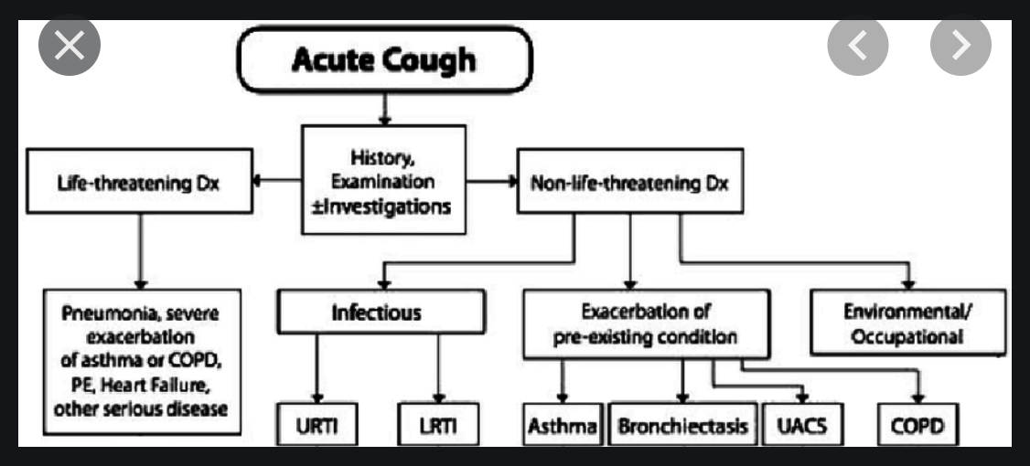

Five Core Principles of Journalism

1. Truth and Accuracy
We should always strive for accuracy; give all the relevant facts we have and ensure that they have been checked. When we cannot corroborate information, we should say so.

2. Independence
Journalists must be independent voices; we should not act, formally or informally, on behalf of special interests whether political, corporate or cultural. We should declare to our editors – or the audience – any of our political affiliations, financial arrangements or other personal information that might constitute a conflict of interest.

3. Fairness and Impartiality
Most stories have at least two sides. While there is no obligation to present every side in every piece, stories should be balanced and add context. Objectivity is not always possible, and may not always be desirable (in the face for example of brutality or inhumanity), but impartial reporting builds trust and confidence.

4. Humanity
Journalists should do no harm. What we publish or broadcast may be hurtful, but we should be aware of the impact of our words and images on the lives of others.

5. Accountability
A sure sign of professionalism and responsible journalism is the ability to hold ourselves accountable. When we commit errors, we must correct them and our expressions of regret must be sincere not cynical.

DEBATE TECHNIQUES APPLIED
TO THEOLOGY, PREACHING AND APOLOGETICS

1. Don’t make “claims” that are unsubstantiated. For example; an Arminian might reject predestination because he “just can’t see it,” to him “it just doesn’t seem fair that God would remove all human choice!” This however, is a claim without authority.

The speaker is appealing to his sense of fairness, rather than the word of God. Similarly, an Augustinian theologian, in defense of his view of God’s sovereignty may claim, “well God has to be in charge of everything.” “If you left things up to people, nothing good would happen!”

This claim is not based on scripture, but, rather, on the Augustinian’s view of humanity. He may be correct; however, the Augustinian has not established his primary point using scriptures, namely, the Sovereignty of God over the affairs of humanity.

2. The used of rejoinder: Rejoinder involves suspending judgment while investigating in the serious manner the claims of those who oppose your theological or apologetical view. It involves looking for the weaknesses of your view while observing the ways in which scripture substantiates some (or all) of your opponent’s viewpoint. It is possible that two seemingly opposing view are supported by the bible text. If there are two seemingly opposing views supported by scripture, the struggle is not to determine which is correct, but how to assimilate both of these views properly into a coherent theology that is currently not being considered. For example; the Westminster Confession affirms BOTH predestination and free will in a well-constructed coherent statement.

3. Address questions directly: It is tempting to ignore questions and propositions for which one has not prepared. One commonly used method of addressing theological and apologetical questions is to ignore the question posed and continue to state one’s own conviction louder than the first time it was expressed. If one is unprepared to answer an objection or another’s point of view, it is better to be honest than to obfuscate by changing the subject. When debating or presenting points of view, if some of those points are unfamiliar, I have found it mutually satisfying to state; “I will research your question (or point of view) more, and would love to reengage at a later time.”

Note: While preaching emphatically, the speaker is seen as more credible when also presenting honestly the opposing view point before presenting their own view.

